The Cosmic Christ
The Target: Transformation
Colossians 3:8-15

Hank's Story

The Cosmic Christ
Restoring The Image

The Cosmic Christ
The Target: Transformation
Colossians 3:8-15

The Cosmic Christ
The Priority of Love

- The ________ Of ________________________ . . . Is _________.

And over all these virtues put on love, which binds them all together in perfect unity.
(Colossians 3:14)

Jesus replied: “ ‘Love the Lord your God with all your heart and with all your soul and with all your mind.’ This is the first and greatest commandment. And the second is like it: ‘Love your neighbor as yourself.’ All the Law and the Prophets hang on these two commandments.” (Matthew 22:37-40)

Let no debt remain outstanding, except the continuing debt to love one another, for whoever loves others has fulfilled the law. The commandments, "You shall not commit adultery,” “You shall not murder,” “You shall not steal,” “You shall not covet,” and whatever other command there may be, are summed up in this one command: “Love your neighbor as yourself.” Love does no harm to a neighbor. Therefore love is the fulfillment of the law. (Romans 13:8-10)

For the entire law is fulfilled in keeping this one command: “Love your neighbor as yourself."
(Galatians 5:14)

The goal of this command is love, which comes from a pure heart and a good conscience and a sincere faith. (1 Timothy 1:5)

Love does not delight in evil but rejoices with the truth. (1 Corinthians 13:6)

Therefore, as God’s chosen people, holy and dearly loved, clothe yourselves with compassion, kindness, humility, gentleness and patience. Bear with each other and forgive one another if any of you has a grievance against someone. Forgive as the Lord forgave you. And over all these virtues put on love, which binds them all together in perfect unity. (Colossians 3:12-14)

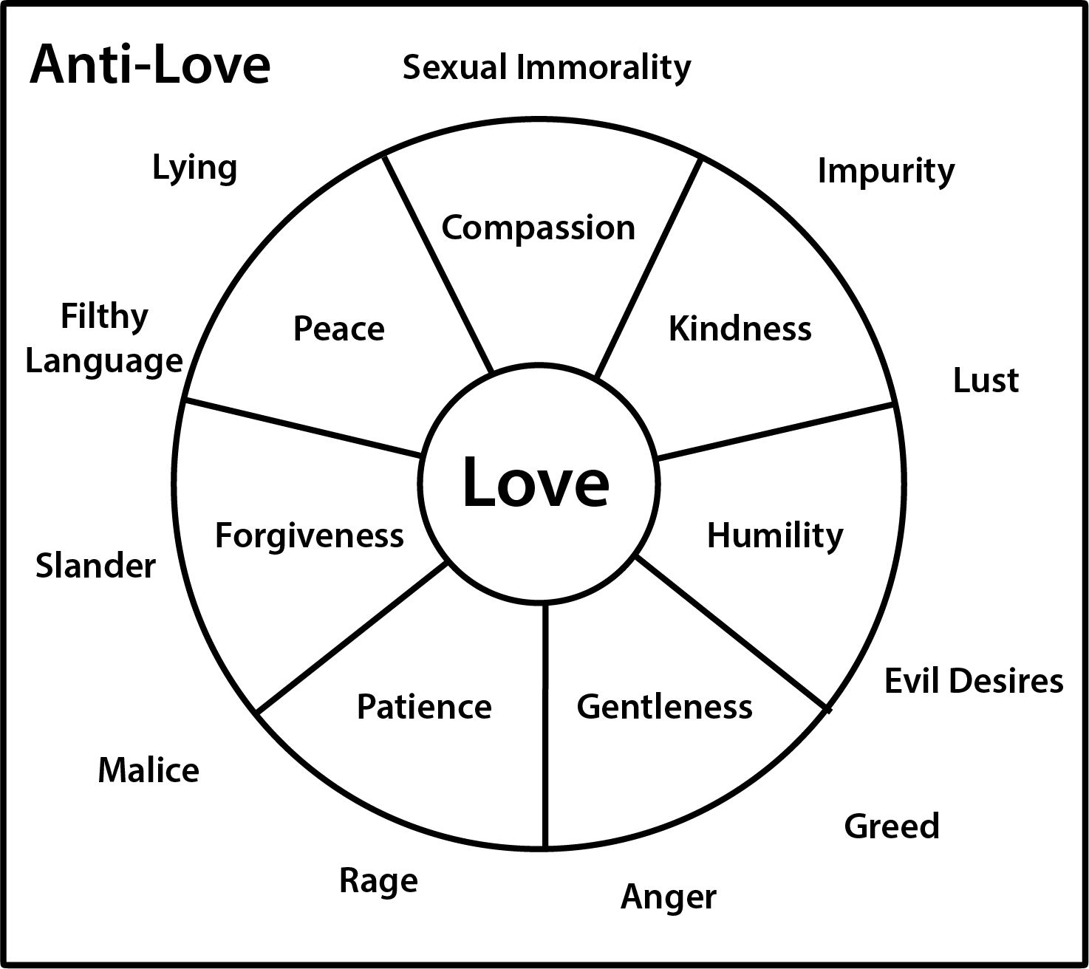

Put to death, therefore, whatever belongs to your earthly nature: sexual immorality, impurity, lust, evil desires and greed. (Colossians 3:5)

But now you must also rid yourselves of all such things as these: anger, rage, malice, slander, and filthy language from your lips. Do not lie to each other, since you have taken off your old self with its practices. (Colossians 3:8-9)

The Cosmic Christ
Three Key Questions

- _______ . . . _____ You _______________ __________________________?

Hank was not changing. He was once a cranky young guy, and he grew up to be a cranky old man. But even more troubling than his lack of change was the fact that nobody was surprised by it. It was as if everyone simply expected his soul would remain withered and sour year after year, decade after decade. No one seemed to be bothered by his condition. It was not an anomaly that caused head-scratching bewilderment. No church consultants were called in. No emergency meetings were held to probe the strange case of this person who followed the church's general guidelines for spiritual life and yet was nontransformed.

The church staff did have some expectations. We expected Hank would affirm certain religious beliefs. We expected he would attend services, read the Bible, support the church financially, pray regularly, and avoid certain sins. But here's what we didn't expect: We didn't expect that he would progressively become the way Jesus would be if he were in Hank's place. We didn't assume that each year would find him a more compassionate, joyful, gracious, winsome personality. . . . So we were not shocked when it didn't happen. We would have been surprised if it did!
(John Ortberg, The Life You've Always Wanted)

- _________ . . . Is _________ ____________?

And over all these virtues put on love, which binds them all together in perfect unity. (Colossians 3:14)

Therefore, as God’s chosen people, holy and dearly loved, clothe yourselves with compassion, kindness, humility, gentleness and patience. Bear with each other and forgive one another if any of you has a grievance against someone. Forgive as the Lord forgave you. (Colossians 3:12-13)

- _________ . . . _____ You ___________________?

