Christ, Culture, & The Cross

The Letter of 1 Corinthians
Acts 18:1-18

The Climb

Christ, Culture, & The Cross
The Letter of 1 Corinthians

Corinth: The Backstory
The City, The Culture & The Church
Acts 18:1-18

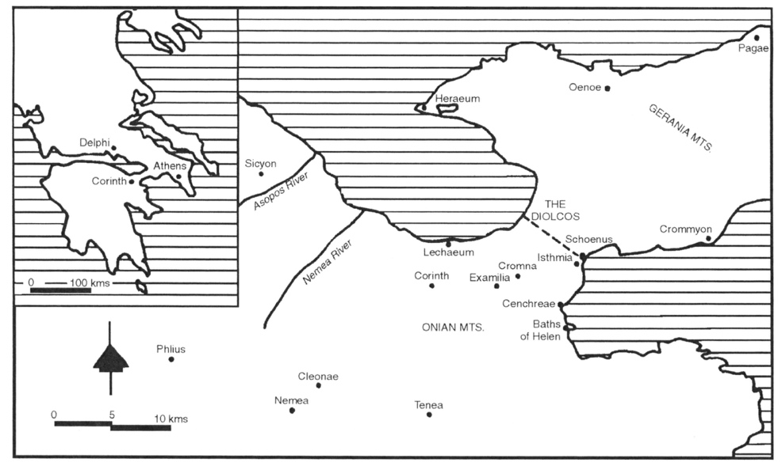

All of this evidence together suggests that Paul’s Corinth was at once the New York, Los Angeles, and Las Vegas of the ancient world. (Dr. Gordon D. Fee)

The traveler who arrived in the mid-first century would pass through the mercantile suburb, beneath colonnaded sidewalks that protected from sun and weather. Ascending the terraces upon which the central city was located, he would see the Asklepieion, with its temple, colonnades and bathhouses, and the Old Gymnasium on his right. Nearby he might have stopped to refresh himself at the beautiful Fountain of Lerna. . . . The water could be clean and safe. . . . Moving closer to the Forum . . . large market buildings, basilicas and the law courts would line the colonnaded street. On his left would be the Baths of Eurycles, public latrines, and the periobolos of Apollo with its famous works of art, and next the great Fountain of Peirene. . . . He would pass beneath the majestic triumphal arch surmounted by two gilded, horse-drawn chariots. . . . The forum itself was a vast open space thronged with merchants, street hawkers, travellers, and local residents. Varicoloured tents covered the market stalls. . . . He would see . . . works of public art: paintings, marble sculpture and works of bronze . . . shrines, sanctuaries and temples . . . shops, stoas, and the administrative offices in the imposing South Stoa . . . dazzling colours.
(Thiselton, A. C. The First Epistle to the Corinthians: A Commentary on the Greek Text, p.20)

Christ, Culture & The Cross
The Key Question

- _______ You ___________________ The _______ Of ______________ . . .

Or The _______ Of _____________?

Brothers and sisters, I could not address you as people who live by the Spirit but as people who are still worldly—mere infants in Christ. (1 Corinthians 3:1)

The problem was not that the church was in Corinth but that too much of Corinth was in the church. (Dr. Gordon D. Fee)

Two roads diverged in the middle of my life
I heard the wise man say
And I took the one less traveled by
And that's made the difference, every night and every day. (Larry Norman, One Way)

